According to the History Channel, what are the 9 theories about the disappearance of Amelia Earhart?

- Amelia & Fred ran out of f_______________ and c________________ into the Pacific Ocean.

- Amelia & Fred landed on G____________ I________________, but died before they could be r___________________.

- Amelia & Fred landed on S_______________________, but was later e_______________________ by the Japanese.

- Amelia was supposed to s______________ on Japan, but instead was c__________________ by them after crashing

- Amelia returned to the USA under a new name of I____________ B_________________.

- Some men thought she became a n_____________ on the island of G________________________________.

- Some people think she crashed on N___________ B_______________ Island.

- Amelia was captured by the J___________________ and became a voice on the Japanese radio with the name of T_____________ R_________________.

- Amelia was captured by the J___________________ and traveled with an officer and little boy to E_______________ I_____________________.

According to The Daily Beast, there are other theories about her disappearance. They repeat some of those listed above, but list the ones that are different.

5. Amelia & Fred were a__________________ by aliens.

6. Fred was a d_________________ who crashed the plane.

8. Amelia and Fred faked their death so they could e_________________.

4. Amelia & Fred died on N___________________________ I_________________, but her body was carried off by c___________________.

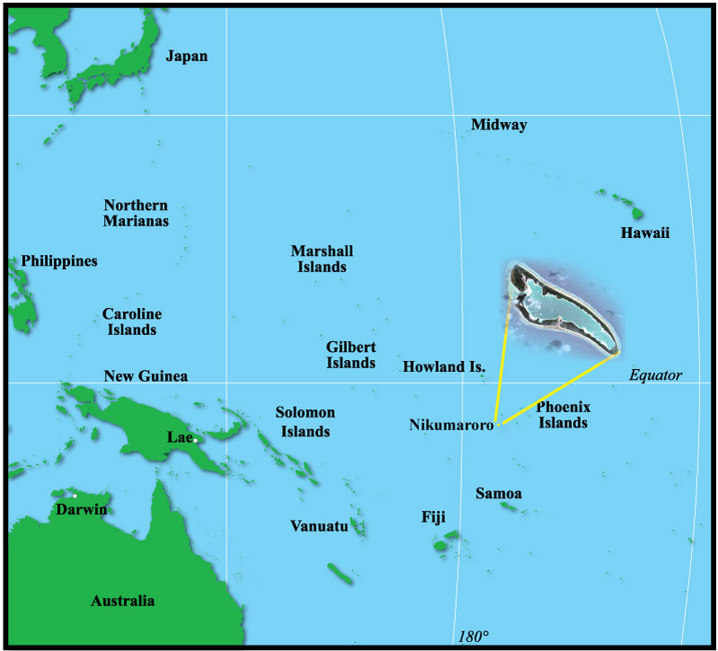
In 1998, NPR (a radio news station) wrote an article about what Gillespie found on Gardner Island (an old name for Nikumaroro Island). What did they find that they thought proved Amelia had been on the island?
b________________
and one s_____________________

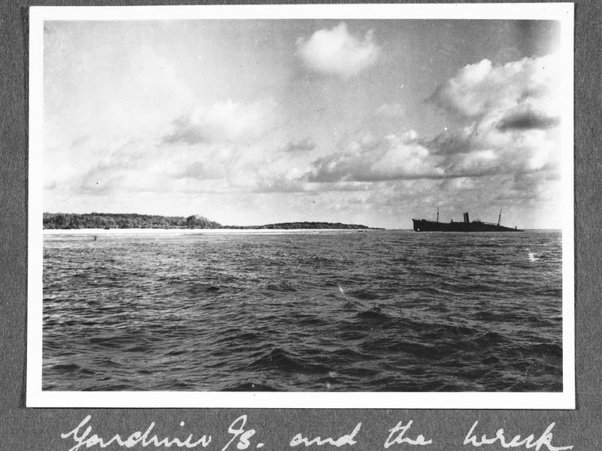
However, in 2012, NPR wrote another article about what Gillespie found in a photo taken near Gardner Island. In the photograph, what did they think they found that belonged to Amelia Earhart?
a piece of her _____________________

In June 2015, Gillespie is returning to Gardner Island and will use a robot to look at the ocean’s floor to see if the plane is there. Do you think the plane will be there?

Circle one: Yes / No
Please write a paragraph that states what you think happened to Amelia & Fred and WHY you think this.

T: ___________________________________________________________________________
______________________________________________________________________________

*: ___________________________________________________________________________
______________________________________________________________________________

0: ___________________________________________________________________________
______________________________________________________________________________

*: ___________________________________________________________________________
______________________________________________________________________________

0: ___________________________________________________________________________
______________________________________________________________________________

^: ___________________________________________________________________________
______________________________________________________________________________

